Dear Friends of the Gumbo Festival:

Join us as we celebrate over 50 years of great Gumbo in Bridge City, Louisiana! Our Festival will be held on October 11th, 12th & 13th, 2024. The festival attracts thousands of people from all over the country as well as the locals. It has a positive impact on the economy of our area and especially in Jeﬀerson Parish and metropolitan New Orleans. We have touted our title of “The Gumbo Capital of the World” since 1973...a mere 50 years ago.

The parishioners of Holy Guardian Angels Mission Church sponsor the Gumbo Festival and all proceeds are used for the maintenance and operation of church the building and properties.

We are asking local businesses and public servants to sponsor our event in the form of a tax- deductible donation to help cover overhead expenses. Your sponsorship will help boost the economy of our area while supporting a worthwhile cause. Please consider one of the opportunities below:

$5000 Donation - Seafood Gumbo Level:
- Corporate 3 x 6 color banner on the Gumbo Festival entertainment stage
- Full color advertisement in our beautiful Gumbo Festival Program Book
(Deadline for program book ad is August 2nd)
- Corporate link on our Gumbo Festival website Sponsorship page
- 8' X 10' booth space to promote your business if desired, deadline (September 27th)
5.) 10 Free admittance into the Fair

$2500 Donation - Chicken Gumbo Level
- Corporate 3’x 6’ color banner on the Gumbo Festival entertainment stage by the stage area
- Full Page photo or printed message in the Gumbo Festival Program Book
(Deadline for program book ad is August 2nd)
- Corporate link on our Gumbo Festival website Sponsorship page
- 8' X 10' booth space to promote your business if desired, deadline (September 27th)
- 5 Free admittances into the Fair

$1000 Donation - Filé Level
- Corporate banner at admission gate (up to 24" X 36" provided by you)
- 1/2-page photo or printed message in the Gumbo Festival Program Book (Deadline for program book ad is August 2nd)
- Corporate link on our Gumbo Festival website Sponsorship page

$500 Donation - Hot & Spicy Level
- Corporate banner at admission gate (up to 12” x 18” provided by you)
- ¼” page printed message in the Gumbo Festival Program Book (Deadline for program book ad is August 2nd)
- Corporate link on our Gumbo Festival website sponsorship page

$250 Donation - Bowl Slurping Level
- Corporate banner at admission gate (up to 12 X 18" provided by you)
- Corporate link on our Gumbo Festival website Sponsorship page

$100 Donation - Friends of the Gumbo Festival Level
1) Corporate link on our Gumbo Festival website Sponsorship page

Please note: No signs can contain the words "Vote For".

We invite you to attend and participate in the opening ceremonies as we celebrate GUMBO in our town. You will surely have a great time!

The deadline for Sponsorships is September 27th, but for those sponsorship levels who are entitled to an ad in the program book, deadline will be August 2st

Fr. Buddy Emile Noel Gumbo Festival Chairman 504-341-9522
504-648-5523

1701 Bridge City Avenue Bridge City, La 70094
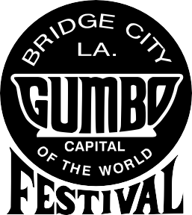

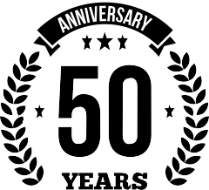

Website: bridgecitygumbofestival.org

Email: Sdavis.fst@gmail.com Phone: 504-481-9201

2024 CORPORATE SPONSOR INFORMATION SHEET

Business Name:

Contact Person:

8’ x 10’ Booth: Yes or No

Business Address:

City: State: Zip:

Contact Phone Number: Fax:

Website:

E-Mail:

Level of Sponsorship: (Circle One)

Seafood Gumbo - $5000

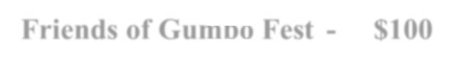

Chicken Gumbo $2500

Filé $1000

Hot & Spicy - $500

Bowl Slurping - $250

Friends of Gumbo Fest - $100

Please indicate if invoicing is necessary from our office, as we are a non-profit (501(c)) organization. Send this sheet with the sponsorship donation (payable to the Bridge City Gumbo Festival) to 1701 Bridge City Avenue, Bridge City, LA 70094 - to the attention of Stephanie Davis.

Stephanie Davis- Rodriguez

